Download the data from yahoo finance. Youll need the data for each stock from Nasdaq and NYSE.

The data suppose to be updated daily at 11:30 pm NY time or if short running time, at the time the report will automatically retrieve the data

2 indicators –

Make for each stock SMA – Smooth moving average. Let me have a box that I can choose the number of days to calculate on. like that:

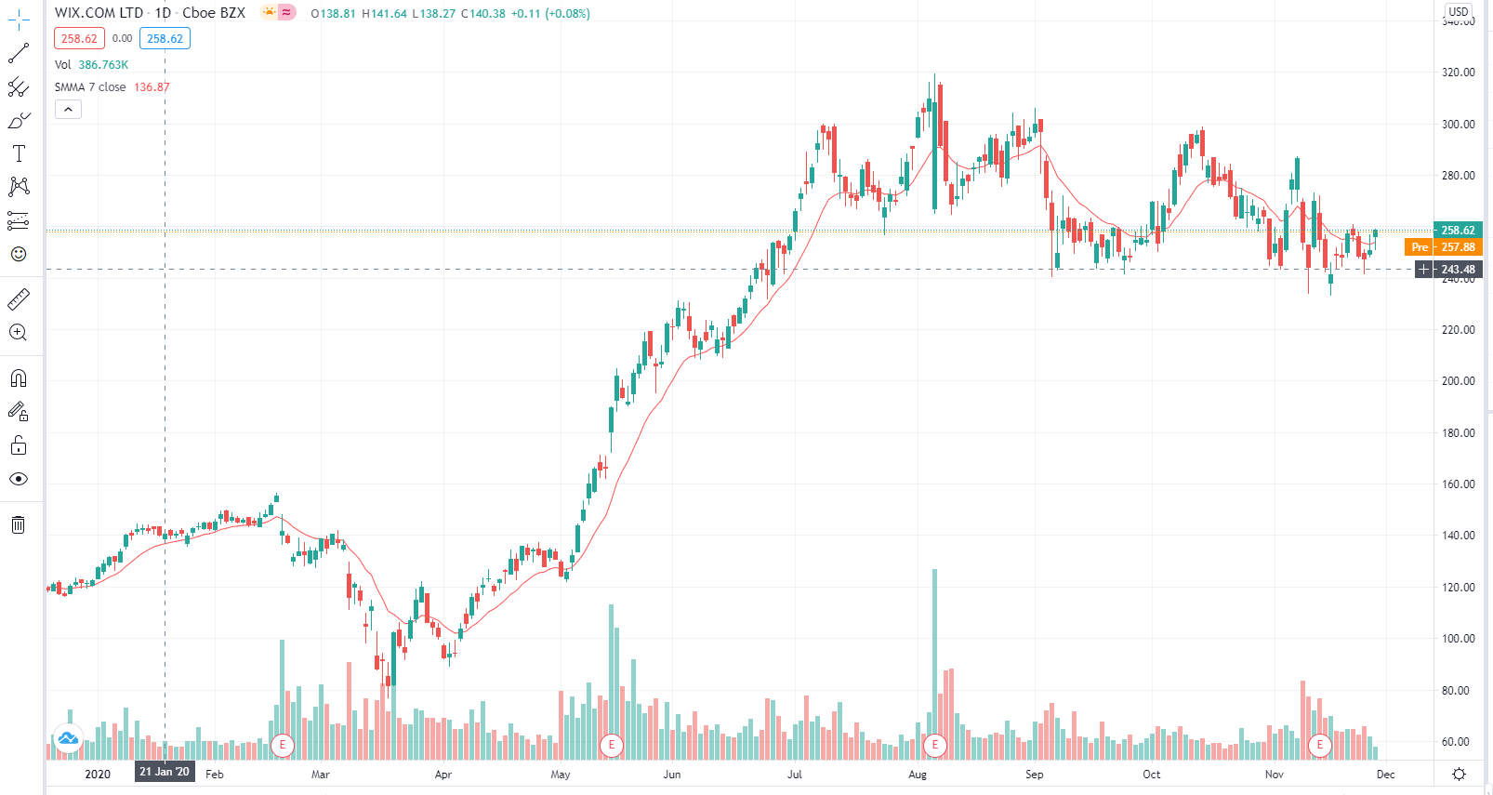

As you can see, the line connects dots that for each day shows the 20 day average before (stock days, only days when the market was open)

Second indicator – RSI

Attached a link to youtube that explains about it. I think you can also retrieve it from yahoo but if not -

<https://www.youtube.com/watch?v=rgVdgR1y1Dg&ab_channel=Trading212>

in the code I want to include only stocks that their market cap is above 2B

first outcome list – stocks I might wanna buy –

last day lowest (out of open, close, high, low) above SMA for the day (also I can decide on the

market cap >2B

RSI below 52 (also I want to be able to change it )

2 days ago RSI < todays RSI

Max (last 50 days [also I want to be able to change it when I want ]) > 1.25[make in parameter, might change at some point] current stocks price

Order by todays volume / last 20 days average volume

Second list – sell

I want to be able to add names of stocks or delete them and it will show me which stocks meet the criteria :

RSI>67

Or

Todays range (high-low) touches the SMA line.

Extras:

If possible, I want it to be sent to my mail address. I want it to automatically happened each day the market is closing. I want to be able to change parameters if needed.

If possible, also show me the graph for each stock that is meeting criteria. Theres add ins that suppose to do it.

If you cant send it through mail its ok, I can also run it and have it in my PC.

I might have many more jobs in this field coming up. Saw many reviews about you and it seems like you are my guy.

Let me know for any questions.